**FARHANA CHOWDHURY**

**SOFTWARE ENGINEERING TECHNOLOGY**

**STUDENT ID: 300812011**

**COMP-305**

**SECTION: 002**

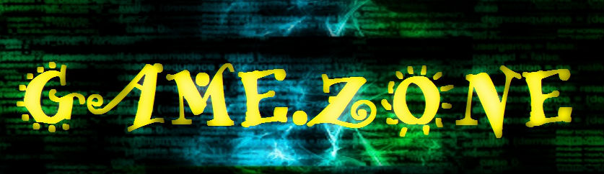

Table of Contents:

1. Company Logo
2. Game Overview
3. Game Controls
4. Interface Sketch
5. Screen Descriptions
6. Player’s Character
7. Hazards
8. Scoring system
9. Sound Index
10. Multimedia Index

**Company Logo**



**Game Overview**

The Space Shooter Game is constructed with a player which is travelling through space and facing obstacles of enemies which come as is asteroids. The player can move up, down and right and left. If the player gets touched by the asteroids, it gets destroyed. The player is equipped with a shooter which shoots bolts towards the asteroids and destroy them. Each time the player hits an asteroid, it gets a point of 10. Once the player is destroyed. If the player dies, the screen displays “Game Over”. The user can restart the game by pressing the “R” key.

**Game Controls**

The game can be controlled by using the following keys

W = Upward

A = Left

D = Right

S = Down

Mouse click = Shoot Bolt

R = Restart

**Interface Sketch**

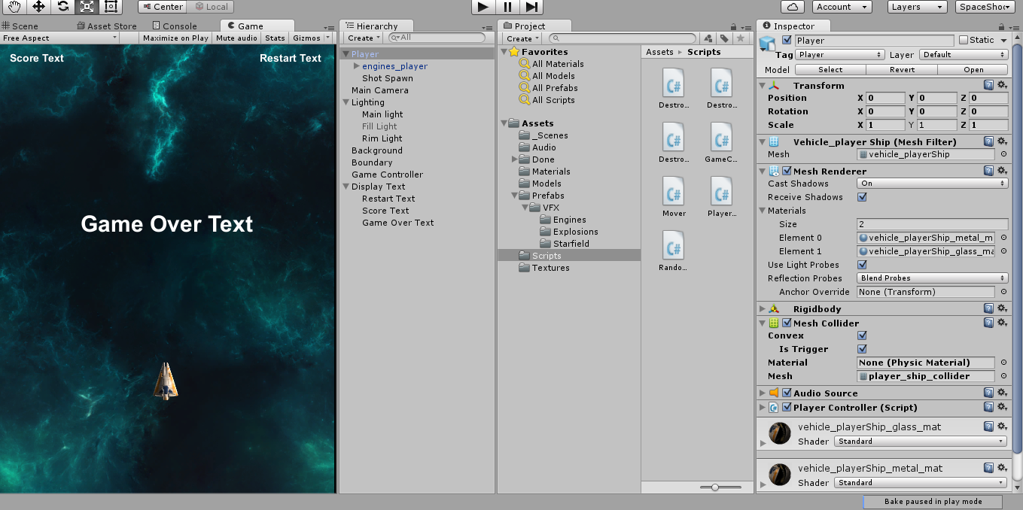

Image Description: Game view of the game

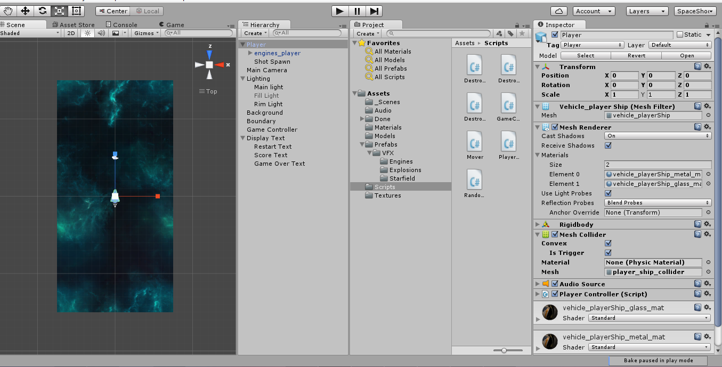

Image Description: Scene view of the game

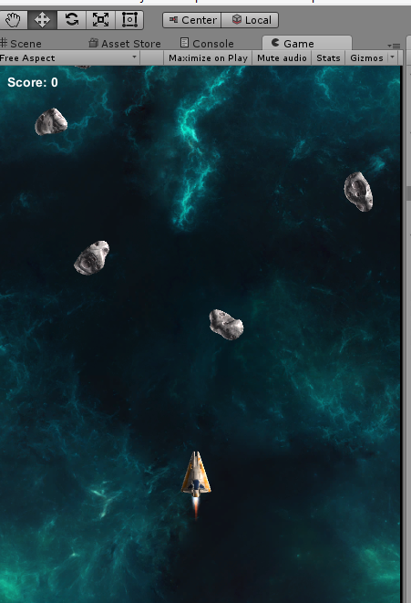

Image Description: Play mode image of the game

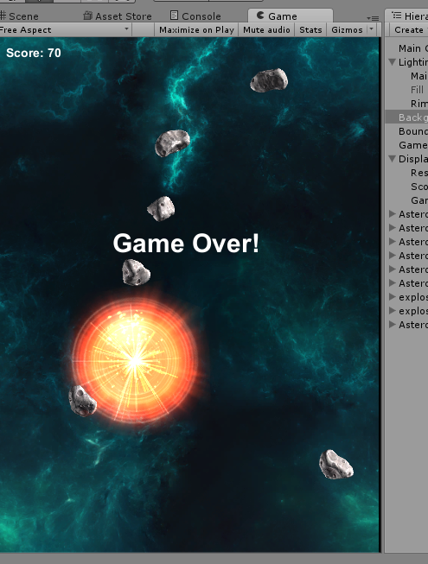

Image Description: Play mode view of the game

**Screen Descriptions**

START:

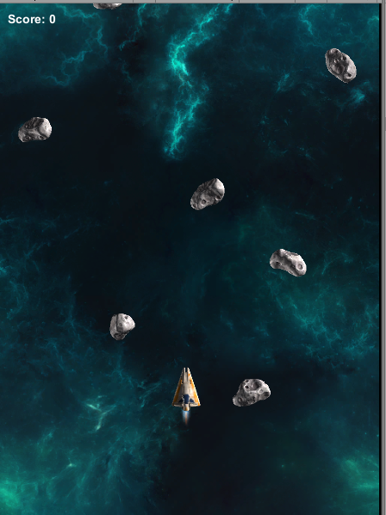

GAME OVER:

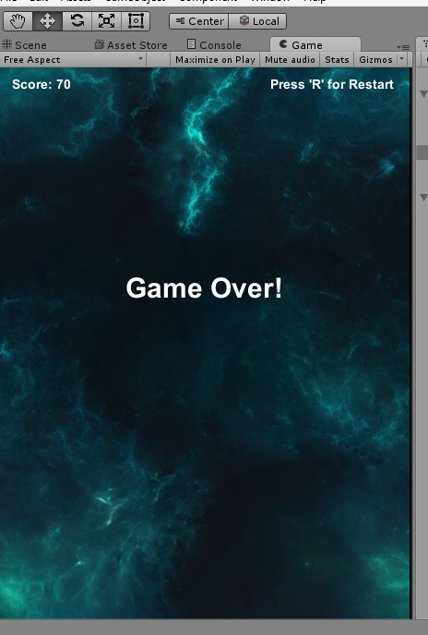

**Player’s Character**

**Hazards**

Asteroids which travel towards the player and destroy it on contact.

**Scoring system**

Each shot gives the user a point of 10 which is accumulated until the player gets destroyed by the asteroids.

**Sound Index**

Audio files used in the games are from the package of the asset from the Space Shooter tutorial.